Methodist Le Bonheur Healthcare Pharmacy Residency Programs
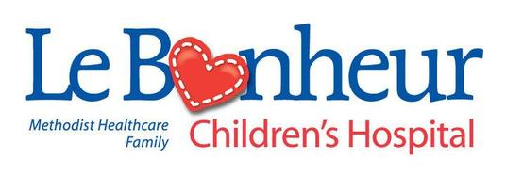
PGY2 Candidate Personal Statement Questions
Candidate Instructions | Please answer each of the following questions. Completed assessment questions should be uploaded to PhORCAS® as a “personal statement.” DO NOT upload a traditional personal statement / letter of intent.

Why do you feel our program is the ideal PGY2 residency program for you (250 word limit)?

What are your ultimate career goals after the completion of PGY2 residency (250 word limit)?

As a PGY1 resident, have you been or will you be involved in the following? (Please answer “Yes” or “No” to each question unless otherwise noted).
- Creating & delivering an ACPE-accredited continuing education program?
  - If yes, what was the time length of the presentation in minutes?
- Creating & delivering a didactic lecture to student pharmacists?
  - If yes, what was the time length of the presentation in minutes?
- Completed a teaching certificate program?
  - If yes, was the program sponsored by a hospital or college of pharmacy?
- Completing an institutional review board application?
- Analyzing data in statistical software & interpreting the results?

